Task 3- **Hello World RESTful Web Service**

1 – Project Structure

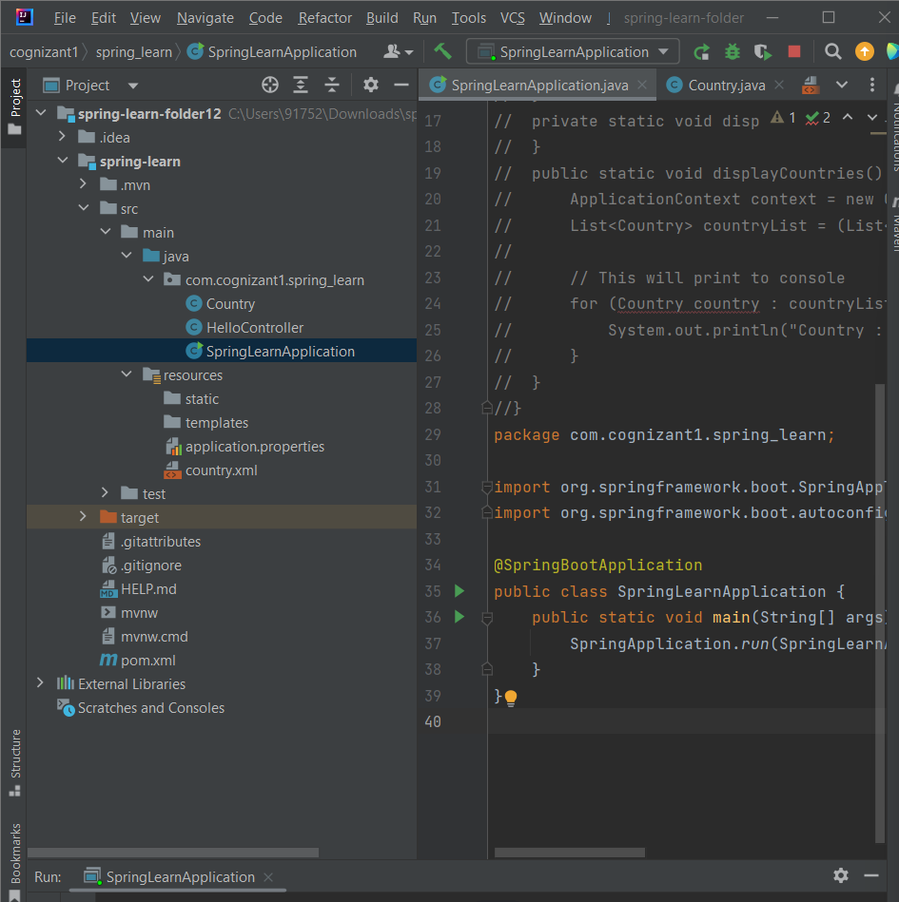

2-SpringApplication.java

package com.cognizant1.spring_learn;  
  
import org.springframework.boot.SpringApplication;  
import org.springframework.boot.autoconfigure.SpringBootApplication;  
  
@SpringBootApplication  
public class SpringLearnApplication {  
 public static void main(String[] args) {  
 SpringApplication.*run*(SpringLearnApplication.class, args);  
 }  
}

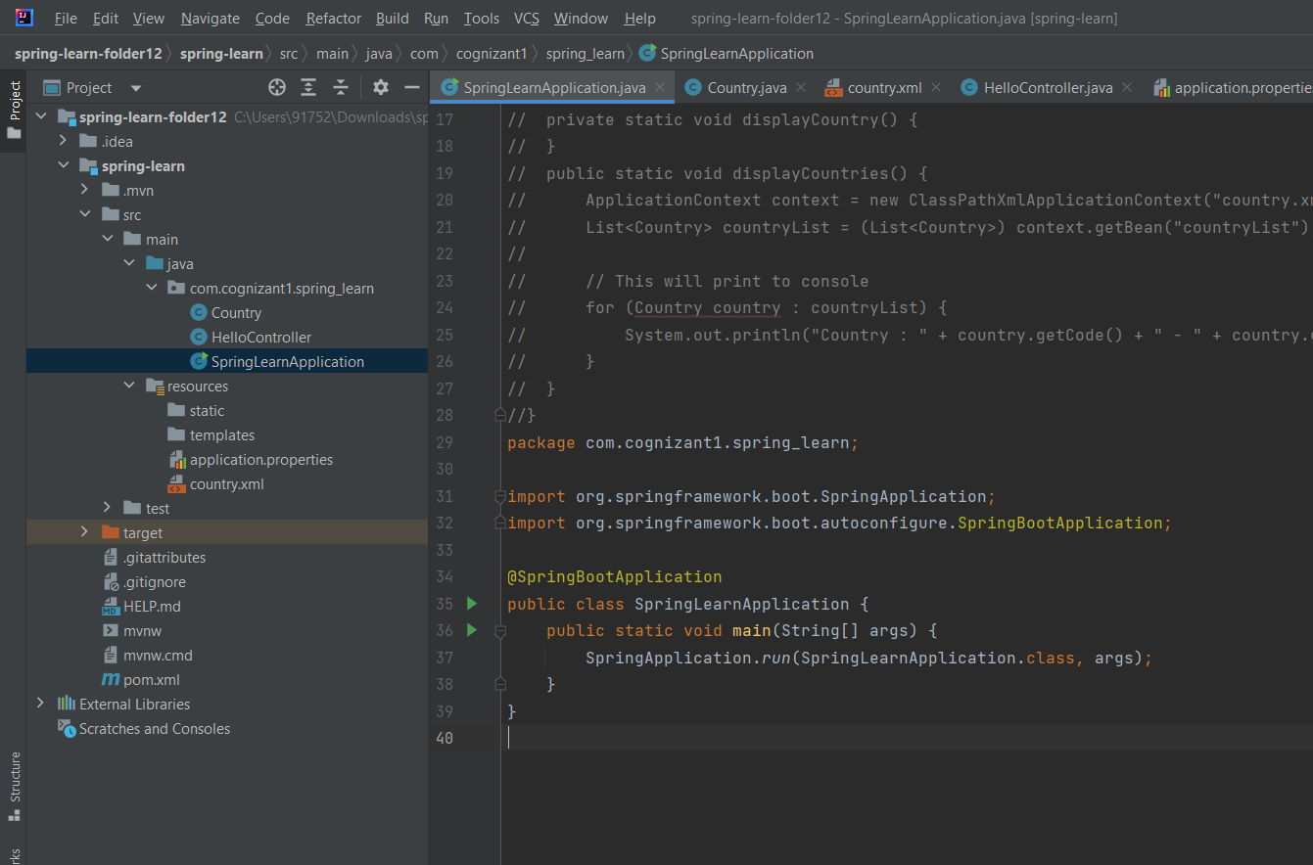

3- HelloController.java

package com.cognizant1.spring_learn;  
  
import org.slf4j.Logger;  
import org.slf4j.LoggerFactory;  
import org.springframework.web.bind.annotation.GetMapping;  
import org.springframework.web.bind.annotation.RestController;  
  
@RestController  
public class HelloController {  
  
 private static final Logger *LOGGER* = LoggerFactory.*getLogger*(HelloController.class);  
  
 @GetMapping("/hello")  
 public String sayHello() {  
 *LOGGER*.info("START: sayHello()");  
 String message = "Hello World!!";  
 *LOGGER*.info("END: sayHello()");  
 return message;  
 }  
}

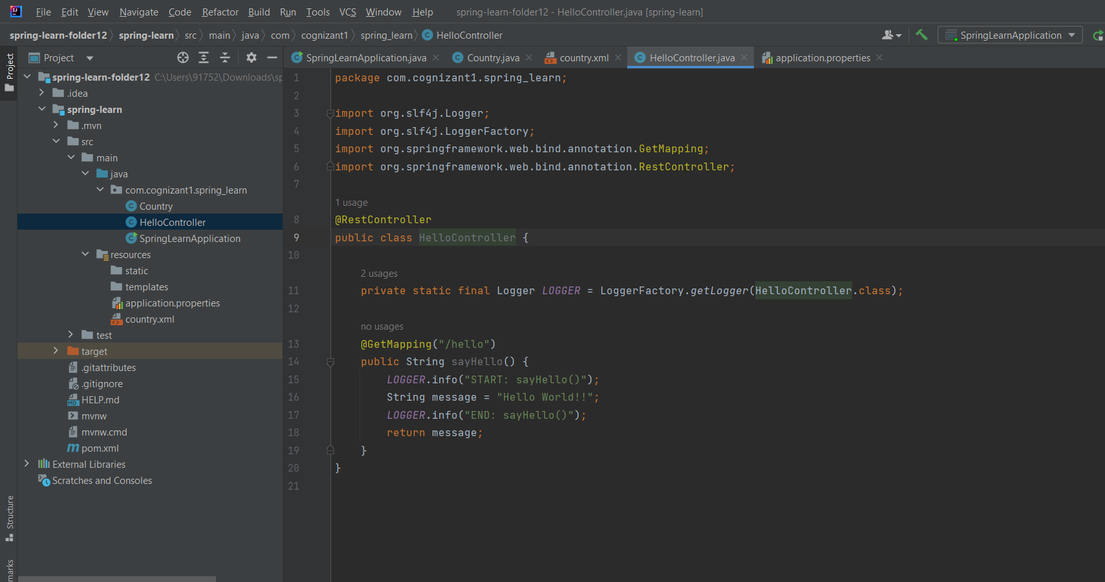

4- Output

